Standard Infection Control Policy

Other formats of this policy can be made available via our management team on 01708 871517

Title of Policy/Guideline and version number | Standard Infection Control Policy: Version 1
Author / Accountable Person | Marionette Zvavamwe, Registered Manager
Creation Date | 31/07/2022
Principal target Audience: | All internal and external stake holders and their families  All staff employed within the company.
Commissioning Body | Management Services
Stake Holders Consulted | Directors, Clinical Leads and Staff
Standards | Care Quality Commission (CQC), Health and Social Care act 2008 Regulated Activities Regulations 2014, World Health Organisation 2009,2022, CDC 2016, Nice Guide Lines, NMC, UKHCA
Implementation Plan | Send to CQC  Availability to All staff  Review compliance with Policy in 6 months  Monitor Feedback for quality and safety related incidents  Local teaching at induction
Approved by: | Marionette Zvavamwe
Date of submission | 01/08/2022
Date for review | September 2025
Date of Validation
Key Words | Infection, Prevention, Policy

Version Control Sheet
Version | Date | Author | Status | Comment
1 | September 2022 | Marionette Zvavamwe | Registering Manager | Creation
2 | September 2023 | Marionette Zvavamwe | Registering Manager | Update
3 | September 2024 | Marionette Zvavamwe | Registering Manager | update

 | CONTENTS: | Page
 | Policy Statement | 3
1 | Introduction | 3
2 | Aims and Purpose of the Policy | 4
3 | Scope | 5
4 | Responsibilities | 5
5 | CapitalPro’s Goal | 7
6 | Infection Control Procedure | 8
7 | Infection Control Principels | 9
8 | Elements of Standard Infection Control Precautions | 11
9 | Risk Assessment / Patient/Client Placement | 12
10 | Hand Hygiene | 13
11 | Respiratory and Cough Hygiene | 14
12 | Personal Protective Equipment | 14
13 | Management Precaution of Exposure Including sharps | 16
14 | Environmental Cleaning | 17
15 | Safe Management of Linen | 18
16 | Handling and Disposal of Clinical and Non-Clinical Waste | 19
17 | Safe Management of Blood and Body Fluid Spillages | 19
18 | Collecting and Handling Speciments | 20
19 | Food Hygiene | 20
20 | Reporting | 20
 | Contact Information
Appendices
Appendix 1
Appendix 2
Appendix 3

Infection control is the name given to a wide range of policies, procedures and techniques intended to prevent the spread of infectious diseases amongst staff and service users. All the staff working in the organisation are at risk of infection or of spreading infection, especially if their role brings them into contact with blood or bodily fluids like urine, faeces, vomit or sputum. Such substances may well contain pathogens that can be spread if staff do not take adequate precautions.
Policy Statement
CapitalPro believes that adherence to strict guidelines on infection control is of paramount importance in ensuring the safety of both service users and staff. As research, examination and medical history is not reliable in the identification of people who are colonised and or infected by pathogens which can be transmitted, it is therefore CapitalPro’s policy that all employee practice and adhere to Standard Infection Control (SIC) at all times and also believes that good, basic hygiene is the most powerful weapon against infection, particularly with respect to hand washing (WHO 2009). Standard Infection control, form the bases of reducing healthcare related infection thus reducing the risk of infection cross contamination between staff and patients (Loveday et al 2014, NHS England).
“Standard precautions aim to protect both health workers and patients by reducing the risk of transmission of microorganisms from both recognized and unrecognized sources. They are the minimum standard of infection prevention and control practices that should be used by all health-care workers, during the care of all patients, at all times, in all settings. When applied consistently, standard precautions can prevent the transmission of microorganisms between patients, health workers and the environment.” (WHO 2022)
The organisation adheres fully and has prepared this policy in line with Outcome 14, Supporting Workers, of the CQC’s Essential Standards and to The Health and Social Care Act 2008, Regulated Activities Regulations 2014 regulation 8 and Code of Practice for Health and Adult Social Care on the Prevention and Control of Infections and Related Guidance (2015).

1.0 Introduction

Infection Control Lead:- Marionette Zvavamwe, marionette@capitalproagency.com phone 01708871517

  - CapitalPro Agency is a provider for domiciliary care for a full range of personal care services in our community.

  - CapitalPro Agency, has a responsibility under The Health and Social Care Act 2008 (Regulated Activities) Regulations 2014 , (Amendment) (Coronavirus) Regulations 2021 and the Care Act 2014 updated 2016 to protect our service users safeguarding their human rights, wellbeing, their health, and enabling them to live as independently as possible in their own home and surroundings.

  - Our services are registered under the CQC who is the independent regulator in England for all health and adult social care.

  - All staff should familiarise themselves with this policy. It is a paramount component in Infection Control.

  - This policy will be part of the mandatory induction for all staff working for CapitalPro and will be made available to all Service Users and other stakeholders.

2.0 Aims and Purpose of the Policy

2.1 The policy aims to:-

- Provide structure, standardised transparent practice, which is to be employed by all staff.

- To comply with statues, guidelines, regulations, and infection prevention standards.

- Highlight CapitalPro’s commitment to Infection and Prevention to our staff and our Service Users ensuring the policies and procedures that underpin that commitment is in place and employed at all levels in support of our TRUST values.

- To prevent and stop the spread of healthcare acquired infection wherever possible and staff and services users are free to report such where policy is not followed.

2.2 The purpose of this policy is to ensure standardised practice within CapitalPro for Standard Infection Control to all our Staff and Service Users.

2.3 Prevent the spread of infection amongst staff, service users and the local community

2.4 Provides guidance, and governance to staff and service in the management and prevention of infection and the use of Standard Infection Control. According to WHO infection control is by far the best weapon again infection.

2.5 This policy was prepared in line with Outcome 14, Supporting Workers, of the CQC’s Essential Standards and to The Health and Social Care Act 2008, Regulated Activities Regulations 2014 regulation 8 and Code of Practice for Health and Adult Social Care on the Prevention and Control of Infections and Related Guidance (2015).

2.6 Be used in conjunction with other CapitalPro’s policies that contribute and embeds infection prevention and management

3.0 Scope

3.1 This policy applies to all staff employed by CapitalPro.

3.2 This policy will be mandatory and will be part of to all new staff including admin staff’s orientation programme.

3.3 all processes herein defined,

4.0 Responsibilities

4.1 Responsibility of the Leadership Team
- The Leadership Team has delegated responsibility for ratifying this policy to the Clinical Governance Committee and in their absence the Registered Manager.
- The responsibility of implementing, report, investigate and liaise with external stake holder any issues and learning in relation to infection control and insuring any change in practice is implemented where necessary.
- Ensure compliance with this policy, updated standards and guidelines ensuring high standards are maintained at all times for the protection of both staff and clients.
- Have authority to challenge staff who fail to comply with good standards of infection control
- Ensure overseeing local infection control, implementation, prevention and implementation issues are reported to the Registered Manager or operations manager in their absents.

4.2 Responsibilities of the Registered Manager and HR / Operations Manager
- The Registered Manager and the HR / Operations are responsible for ensuring that this policy is enforced.
- Ensure the infection control procedures effective and robust in the prevention and management of the acquisition of Healthcare Associated Infection and the spread of transient organisms.
- Has responsibility for ensuring that all concerns in regard to infection control will be investigated, unless there is conflict of interest on the registered manager’s / HR / Operations managers part, and the learning disseminated to all staff.
- Ensure Infection Control prevention and management of the Service user is in collaboration with external stakeholders, national agencies and guidelines in combating the prevention and spread of infection.
- Liaise with relevant external and internal stake holders including multi-agency involvement in infection prevention and management and follow their guidelines and instructions.
- Ensuring that all staff, service users and outside stake holders have access to this policy and that staff attend all relevant training.
- All educational records and mandatory training records pertaining to infection control are updated periodically and that training is part of the mandatory induction programme.
- Monitor, develop and implement new national guidelines, activities which may be announced due to global, national or local infection control threats.
- Ensure that supplies and procurement relevant and relating to infection control consumables are provided and readily available at the point of care and fit for purpose to enable compliance with this policy and government announced guidelines.

4.3 The Clinical Governance Committee
- Have responsibility for ensuring that any incidents or concern associated with infection control are appropriately investigated and that any actions identified as part of these investigations are actioned. In their absence the Registered manager undertakes this responsibility with the Operations Manager.
- Policies and procedures are continually audited and revised to address, prevent and action any concerns or reports of abuse and or harm.
- Provide expert advice and monitor compliance with this policy.

4.4 Registered Manager
- Has overall responsibility and safety of the staff and service users
- Has the responsibility to ensure that all staff have received appropriate training and have been signed off as competent to carry out the duties and the documentary evidence of the assessment should be made available.
- Ensure monitoring of infection control data and reporting requirements are met.
- Ensures auditing of this policy on an annual basis.
- Ensures the risk assessments are undertaken for all Service Users.
- Ensure all staff have a freedom to speak up and be listened to.
- Ensure the culture and ethos of the company promotes infection prevention, control and management and promotes freedom to speak up.
- Ensure any actions identified post shortfall investigations have been implemented, shared and duty of candour undertaken and documented.
- Report and liase with outside stakeholders were infection control issues are of national concern.

4.5 The Staff
- Ensure they have received training at induction and any further relevant training where required in accordance with their employment contract.
- Have joint responsibility for ensuring that this policy is adhered and that their practice in relation to infection control is safe and consistent and that patient safety is always maintained.
- Ensure they are aware of the procedure in place for reporting to the management and the escalation process.
- Carry out a dynamic risk assessment and use appropriate standard infection control prevention.
- Promote current evidence based infection control practice in line with CapitalPro policies.
- Participate in any relevant infection control audit.
- Participate where needed occupational health screening.
- Staff are also responsible for highlighting, through CapitalPro’s Risk Management structures, any clinical incidents or near misses associated with their service delivery in connection with infection control.
- Report to CapitalPro’s management any act they consider a concern in line with infection control.
- Have a responsibility to cooperate in the event of investigation of any allegation and or incident.
- Ensure they are up to date with their annual statutory mandatory training including regular updates.

4.6 The Team Leader
- All team leaders are responsible for ensuring that all their staff has access to this policy.
- They are responsible for ensuring that this policy is implemented within their local area and that all recommendations and actions, following audit results, are followed through and evidenced.
- None compliance reported to Registered Manager

4.7 Students
- All students within the Company have a supernumerary status in accordance to the student bodies. Their designated Supervisors and assessors are responsible for ensuring that the student is taught the correct practice while on the placement and that they are aware of this policy.

5.0 CapitalPro’s Goals

5.1 All The goals of the organisation are to ensure that:
- Service users, their families and staff are as safe as possible from acquiring infections through work-based activities.
- All team leaders are responsible for ensuring that all their staff has access to this policy.
- All staff at Capitalpro are aware of and put into operation basic principles of infection control
- Service users are empowered to make decisions about their healthcare which will protect them from unnecessary infection risks.

5.2 CapitalPro will adhere to infection control legislation:
- The Health and Safety at Work Act, etc 1974 and the Public Health Infectious Diseases Regulations 1988, which place a duty on the organisation to prevent the spread of infection
- The Reporting of Incidents, Diseases and Dangerous Occurrences Regulations 1995 (RIDDOR), which place a duty on the organisation to report outbreaks of certain diseases as well as accidents such as needle-stick accidents
- The Control of Substances Hazardous to Health Regulations 2002 (COSHH), which place a duty on the organisation to ensure that potentially infectious materials within the organisation are identified as hazards and dealt with accordingly
- The Food Safety Act 1990

6.0 Infection Control Procedures

“Standard precautions aim to protect both health workers and patients by reducing the risk of transmission of microorganisms from both recognized and unrecognized sources. They are the minimum standard of infection prevention and control practices that should be used by all health-care workers, during the care of all patients, at all times, in all settings. When applied consistently, standard precautions can prevent the transmission of microorganisms between patients, health workers and the environment.”(WHO 2022)

6.1 Service In this organisation:
- All staff are required to make infection control a key priority and to act at all times in a way that is compatible with safe, current, evidence based and effective infection control practice
- The management of CapitalPro will make every effort to ensure that staff working in the homes of service users have access to sufficient facilities and supplies of appropriate equipment to ensure that they can implement effective infection control procedures and techniques
- Any staff who does not feel that they have access to sufficient facilities and supplies of appropriate equipment to ensure that they can implement effective infection control procedures and techniques have a duty to escalate to their team leaders on first instance, then management team or Registered Manager.

7.0 Infection Control Principles (CDC 2016)

“Infection prevention and control (IPC) is a practical, evidence-based approach preventing
patients and health workers from being harmed by avoidable infections. Effective IPC
requires constant action at all levels of the health system, including policymakers, facility
managers, health workers and those who access health services. IPC is unique in the field
of patient safety and quality of care, as it is universally relevant to every health worker and
patient, at every health care interaction. Defective IPC causes harm and can kill. Without
effective IPC it is impossible to achieve quality health care delivery.”(WHO 2022)

7.1 How Infections Spread:

An infection occurs when germs enter the body, increase in number, and cause a reaction of the body.
Three things are necessary for an infection to occur: (cdc.gov 2016)
- Source: Places where infectious agents (germs) live (e.g., sinks, surfaces, human skin)
- Susceptible Person with a way for germs to enter the body
- Transmission: a way germs are moved to the susceptible person

7.2 Source

“A Source is an infectious agent or germ and refers to a virus, bacteria, or other microbe.
Germs are found in many places. People are one source of germs including:
- Patients / Clients
- Healthcare workers
- Visitors and household members
People can be sick with symptoms of an infection or colonized with germs (not have symptoms of an infection but able to pass the germs to others).
Germs are also found in the healthcare environment. Examples of environmental sources of germs include:
- Dry surfaces in patient care areas (e.g., bed rails, medical equipment, countertops, and tables)
- Wet surfaces, moist environments, and biofilms (e.g., cooling towers, faucets and sinks, and equipment such as ventilators)
- Indwelling medical devices (e.g., catheters and IV lines)
- Dust or decaying debris (e.g., construction dust or wet materials from water leaks)”

7.3 Susceptible Person

“A susceptible person is someone who is not vaccinated or otherwise immune, or a person with a weakened immune system who has a way for the germs to enter the body. For an infection to occur, germs must enter a susceptible person’s body and invade tissues, multiply, and cause a reaction.
Devices like IV catheters and surgical incisions can provide an entryway, whereas a healthy immune system helps fight infection.
When patients are sick and receive medical treatment in healthcare facilities, the following factors can increase their susceptibility to infection.
- Patients in healthcare who have underlying medical conditions such as diabetes, cancer, and organ transplantation are at increased risk for infection because often these illnesses decrease the immune system’s ability to fight infection.
- Certain medications used to treat medical conditions, such as antibiotics, steroids, and certain cancer fighting medications increase the risk of some types of infections.
- Lifesaving medical treatments and procedures used in healthcare such as urinary catheters, tubes, and surgery increase the risk of infection by providing additional ways that germs can enter the body.

Recognizing the factors that increase patients’ susceptibility to infection allows providers to recognize risks and perform basic infection prevention measures to prevent infection from occurring.”

7.4 Transmission

“Transmission refers to the way germs are moved to the susceptible person.
Germs don’t move themselves. Germs depend on people, the environment, and/or medical equipment to move in healthcare settings.
There are a few general ways that germs travel in healthcare settings – through contact (i.e., touching), sprays and splashes, inhalation, and sharps injuries (i.e., when someone is accidentally stuck with a used needle or sharp instrument).
- Contact moves germs by touch (example: MRSA or VRE). For example, healthcare provider hands become contaminated by touching germs present on medical equipment or high touch surfaces and then carry the germs on their hands and spread to a susceptible person when proper hand hygiene is not performed before touching the susceptible person.
- Sprays and splashes occur when an infected person coughs or sneezes, creating droplets which carry germs short distances (within approximately 6 feet). These germs can land on a susceptible person’s eyes, nose, or mouth and can cause infection (example: pertussis or meningitis).
  - Close range inhalation occurs when a droplet containing germs is small enough to breathe in but not durable over distance.
- Inhalation occurs when germs are aerosolized in tiny particles that survive on air currents over great distances and time and reach a susceptible person. Airborne transmission can occur when infected patients cough, talk, or sneeze germs into the air (example: TB or measles), or when germs are aerosolized by medical equipment or by dust from a construction zone (example: Nontuberculous mycobacteria or aspergillus).
- Sharps injuries can lead to infections (example: HIV, HBV, HCV) when bloodborne pathogens enter a person through a skin puncture by a used needle or sharp instrument.”

8.0 Elements of Standard Infection Control Precautions (WHO 2022)

They are the minimum standard of infection prevention and control (IPC) practices that
should be used by all health-care workers, during the care of all patients, at all times, in all
settings. When applied consistently, standard precautions can prevent the transmission of
microorganisms between patients, health workers and the environment. (WHO 2022)

8.1 Key Elements of Standard Infection Control
- Risk assessment / Patient Placement
- hand hygiene
- respiratory hygiene and cough etiquette
- personal protective equipment
- aseptic technique
- safe injections and sharps injury prevention
- environmental cleaning
- handling of laundry and linen
- waste management
- decontamination and reprocessing of reusable patient care items and equipment.
- Food Hygiene

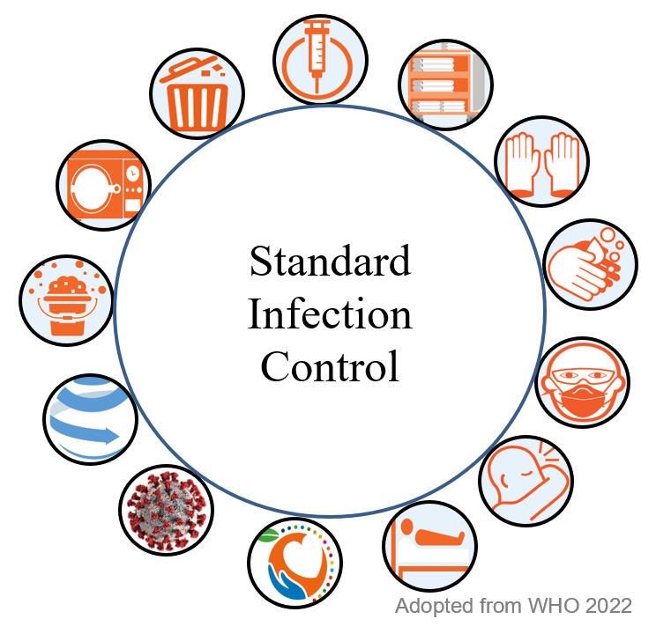

9.0 Risk Assessment / Patient (Client) Placement

Prior to accepting a patient from other care setting, or as a new client, a prompt risk assessment must be carried out and there after continuously reviewed throughout the contract. The infection risk assessment must be clearly documented in the client’s file stating clearly if isolation is required, and given advise from the Registered manager documented within the assessment.

Clients who may present an infection control risk include:
  - Clients who are have recently tested Positive for Covid
  - With loose stool, diarrhea, vomiting, a rash which is unexplained, fever or respiratory symptoms.
  - Known to have had Multi-drug Resistant Organism like MRSA, CPE

  - Staff Should Make a Routine of:
- Assessing the risk of exposure to blood and body fluids, secretions/ excretions, splashes and/or sprays or contaminated surfaces before any health care activity
- Select the appropriate actions to reduce the risk of exposure to infectious agents
- Ask themselves prior to any client interaction:
  - Do I need protection for what I am about to do because there is a risk of exposure to blood and body fluids, secretions, excretions, splashes and/or sprays ?
  - Do I need protection for what I am about to do because the client has symptoms of undiagnosed infection (e.g. fever, cough, diarrhoea)?
  - Do I need protection for what I am about to do because the client has symptoms of an undiagnosed infection (e.g. fever, cough, diarrhoea), requiring Transmission-based Precautions?
  - Do I need protection for what I am about to do because the client has a known infection, requiring transmission-based precautions?

10.0 Hand Hygiene
This organisation believes that the majority of cross-infection in a care environment is caused by unwashed or poorly washed hands which provide an effective transfer route for micro-organisms. The organisation believes that regular, effective hand washing and drying, when done correctly, is the single most effective way to prevent the spread of communicable diseases (WHO 2022). Staff who fail to adequately wash and dry their hands before and after contact with service users may transfer micro-organisms from one service user to another and may expose themselves, service users and the public to infection.
In this organisation we expect all staff to refer to the five moments of hand hygiene (Appendix 1):
- all staff should ensure in addition to the five moments of hand hygiene that their hands are thoroughly washed and dried:
- between seeing each and every service user where direct contact is involved, no matter how minor the contact
- after handling any body fluids or waste or soiled items
- after handling specimens
- after using the toilet
- before handling foodstuffs
- before and after any care or clinical activity
- hands should be washed thoroughly — liquid soaps and disposable paper towels should be used rather than bar soaps and fabric towels whenever possible
- all cuts or abrasions, particularly on the hands, should be covered with waterproof dressings at all times
- ordinary soap is considered to be effective for routine use in removing dirt and reducing levels of transient micro-organisms on the skin to acceptably safe levels
- the use of antiseptic or antimicrobial preparations is recommended if service users are known to have an infectious disease or are colonised with antibiotic-resistant bacteria, such as Methicillin Resistant Staphylococcus Aureus (MRSA)
- antiseptic hand washing solutions may also be used in situations where effective hand washing is not possible
- The use of alcohol based hand rubs products (ABHR)for hand decontamination is not intended to replace washing hands with soap and water but rather to supplement hand washing where extra decontamination is required or to provide an alternative means of hand decontamination in situations where standard facilities are unavailable or unacceptable (for example, between service users or in unsanitary conditions). These should be used near to the point of care as possible, See appendix 2 – How to Hand Rub)
- to be effective hands should be thoroughly washed before the use of an alcoholic rub and again after the procedure or patient contact has ended.
- Keep finger nails clean short, nail polish free, artificial nails free
- Jewellery especially rings with ridges and stone must not be worn.
- Only wedding bands should be worn on duty while giving personal care as pathogens can harbour underneath nails and jewellery.

11.0 Respiratory and Cough Hygiene

Cross-trasmission of respiratory illness/pathogens can be minimized by respiratory and cough hygiene.

11.1 Staff should refer to appendix 3:
- Catch it - All staff are encouraged to use a disposable tissue to cover their nose and mouth when coughing, sneezing, wiping or blowing their nose.
- Bin it – Use a waste bin to dispose of all used tissues after use.
- Kill it – perform hand hygiene immediately after coughing, sneezing, wiping, or blowing their nose, or after contact with respiratory secretion or any items or object contaminated by these respiratory secretion.
- If staff cannot wash their hands due to nu running water, staff may use ABHR and at the earliest opportunity to was their hands using their hands.
- Avoid touching you face, eyes, nose or mouth.

12.0 Person Protective Equipment (PPE)
The Nice guidelines 2012 state that the primary use of PPE by staff is for protection and reducing the chances of transmitting infection, micro-organisms from staff to clients and the environment.

12.1 The use of Protective Clothing
- Capitalpro will provide all staff with adequate and suitable personal protective equipment and clothing
- All staff should who are at risk of coming into direct contact with body fluids or who are performing personal care tasks should use disposable gloves and disposable aprons.
- The registered Manager has the responsibility for ordering and ensuring that supplies of gloves and aprons are readily available and accessible.

12.2 Selecting appropriate PPE
- Staff must base their selection of PPE on the risk assessment and the risk of contaminating their skin, and clothing from body fluids, blood excretions and secretions. They should consider
  - The PPE’s barrier effect (Nice 2012)
  - Contamination risk
  - Task at hand
  - Knowledge of already identified infection control risk

12.3 Gloves
- Gloves can be used to reduce the risk of infection between staff and clients.
  - Single use
  - Must be disposed of in a designated contaminated waste bin
  - Must be changed between client’s different procedures.
  - Can reduce likelihood of contact dermatitis if staff are exposed to chemical agents.
  - Staff are to practice hand
- CapitalPro only supplies latex free gloves only but in the event of suppliers issues, all staff who have latex allergy must report this to their team leader or management team
- Gloves should only be worn when performing duties where necessary and not substituted for hand washing. Some indication may include
  - Emptying Cather bags or stoma bags
  - Wound Management
  - Aseptic non touch technique
  - Washing a client
  - Bathing or Showering a client
  - Changing Pads
  - Worn when in direct contact with blood and body fluids
  - Worn when in contact with non-intact skin or mucous membrane
  - Contamination risk
  - Covid Clients
- Staff must perform hand hygiene with soap and water immediately after removing their gloves and their task if finished
- The use of sterile gloves should be for aseptic techniques only.
- Glove prolonged use may cause adverse reactions and skin sensitivity (WHO 2022)
- Any member of staff who suspects that they or a service user might be suffering from an allergic reaction to the latex gloves provided should stop using them immediately and inform their line manager. They should then consult their GP.

12.4 Aprons and Gowns Should be worn:
- To protect skin and prevent soiling of clothing during activities that are likely to generate splashes or sprays of blood, body fluids, secretions or excretions.
- If splashing or spraying is anticipated, a waterproof apron should be worn over the gown
- Remove the soiled gown as soon as possible and perform hand hygiene.
- Staff should be training to use sterile gown before using to avid contamination.

12.5 Face Protection:
- All staff must perform a risk assessment to determine the exposure and level of protection required.
- Facial protection, face masks are single use only, shields or goggles could be single use or re-usable please check before use.
- Face masks such as FFP2 and FFP3 staff need training before use FIT Training, these are worn to protect staff from airborne particles, eg covid, flu strains and MDRTB.

13.0 Management prevention of exposure including Sharps rocedures

13.1 The Disposable of Sharps (e.g. Used Needles)
- Staff are encouraged to avoid using sharps whenever possible, where it is unavoidable it is important to handle and dispose of the sharps correctly to reduce the risk of exposure to blood borne viruses.
- Staff must adhere to the following:-
  - Sharps are single use only unless they are pens injection devices
  - Not pass sharps from person to person
  - Must not re-sheath sharps
  - User is responsible for the disposal
  - Sharps should never be disposed of in ordinary or clinical waste bags.
  - Always dispose of sharps in the designated sharps box.
  - Dispose of sharps at the point of use.
  - Make use of sharps boxes with trays taken to point of use.
  - Sharp boxes should never be overfilled.
  - Staff should never attempt to force sharps wastes into an over-filled box
  - Always ensure sharps containers are dated and labeled with service users details when placed in use or removed.
  - Used, filled boxes should be sealed and stored securely until collected for incineration according to individual arrangements

13.2 Procedure for Sharps Injury
- Staff are encouraged follow the guide for managing prevention of exposure if sharps injury occurs with a potentially contamined needle or sharp.
  - Encourage bleeding if the skin is broken
  - wash the area immediately under cold running water
  - use water proof dressing to cover the site.
  - ensure that an incident form is filled in
  - report the injury to their line manager immediately
  - make an urgent appointment to see a GP or, if none are available, Accident and Emergency
13.3 Staff’s duty to others
- Staff are encouraged cover all cuts and abrasions in any area where skin is exposed using waterproof dressing
- All mandatory vaccinations must be up to date other wise staff cannot work.
- All staff must obtain a hepatitis B vaccination as they may come into contact with blood and body fluids.
- Staff may be restricted in some cases to clients infected with Chickenpox, Measles, Rubella especially if pregnant.
- Staff to be aware of own immune and skin disorders and report this to team leaders and Registered Manager to seek advice.
- Staff should stay away from work if they pose an infection risk especially if illness is communicable to others it is diarrhoea & vomiting and Covid.

14.0 Environmental Cleaning

If Capitalpro is responsible for the clients environmental cleaning, staff should be aware of the processes in place as environmental cleaning is fundamental and essential for preventing and controlling infection.

At CapitalPro staff may be given cleaning duties. Cleaning removes dust, soil

14.1 Cleaning Processes:
- Routine Cleaning
  - Basic level of cleaning as per schedule agreed with the client
  - Use warm tap water and client agreed detergent or wipes to clean surfaces and equipment.
  - Check with your team leader or check the client’s folder for routine and requirements.
  - For non-infected clients.
- Disinfection
  - May be ordered to reduce micro-organism after infections or as routine.
  - Use of agreed chemicals is essential
  - Chlorine-releasing agents are the chemical of choice at Capitalpro.
  - Always check with client file in case of allergies.
- Enhanced Clean
  - Used when the client is known or suspected to have infection
  - Clean all surfaces with touching reach of the client
  - Use Actichlor Plus solutions
  - Always check client file in case of allergies
  - If in doubt check with team leaders or Registered Manager.

15.0 Safe Management of Linen

15.1 Handling linen
- Client’s linen should be handled as per the service user’s agreement
- Ensure the clean linen is stored in the appropriate designated area.
- Used linen should be placed in designated bags
- Infected linen should be handled with care with appropriate PPE

15.2 Staff should not
- Wash linen or rinse linen,
- Client’s used linen should not be placed on the floor or any other surface it should go directly into designated laundry bag.
- Rehandle used linen once baged.
- Overfill linen bags.

16.0 Handling and Disposal of Clinical and Non Clinical Waste

In order to comply with legislation, the handling and disposal of waste should be handled
as follows:
- Staff should ensure waste is disposed of in the agreed appropriate way as per client’s fold
- It is the responsibility of staff for the safe disposal of waste.
- Staff should ensure they have had waste management training
- Segregation of appropriate waste stream at point of disposal is essential for infection control and successful and sustainable waste management. (Who 2020)
- treat waste contaminated with blood, body fluids, secretions and excretions as hazardous infectious waste, in accordance with local regulations
- Dispose of sharps in accordance with management and prevention of exposure
- All clinical waste should be disposed of in such a way that is compliant with the law and with locally agreed arrangement and protocols
- Please refer to Clint’s folder for bespoke arrange for each client.
- Non-clinical waste should be disposed of in normal way as agreed

17.0 Safe management of Blood and Body Fluid Spillages

Cleaning and Procedures for the Cleaning of Spillages
- It is Staff should treat every spillage of body fluids or body waste as quickly as possible and as potentially infectious to comply with the Health and Safety at work Act (1974)
- Before cleaning up spillages staff should always carry out a risk assess
- When cleaning up a spillage staff should wear protective gloves and aprons and use the disposable wipes provided wherever possible after risk assessment.
- Ensure area is secured to prevent further spillages and contamination to protect staff and client.
- Staff are to use designated agreed disinfectant
- Staff must be mindful that the spillage may be toxic
- Always refer to your mandatory training in doubt or seek advice from team leaders and Registered Manager.

18.0 Collecting, Handling of Specimens

- Specimens should only be collected if ordered by a GP. i.e. stool, urine sample etc
- All specimens should be treated with equally high levels of caution.
- Specimens should be labelled clearly and packed into self-sealing bags before being taken to the doctors.
- Use only the containers provided by the requesting GP.
- Only use the designated areas specified for the specimens once taken.
- Non-sterile gloves should be worn when handling the specimen containers and hands should be washed afterwards.

19.0 Food Hygiene
- All staff should adhere to the organisation’s food hygiene policy and ensure that all food prepared in service users homes for service users is prepared, cooked, stored and presented in accordance with the high standards required by the Food Safety Act 1990 and the Food Hygiene (England) Regulations 2005.
- Any member of staff who becomes ill while handling food should report at once to his or her team leader or Registered via the agency office.
- Staff involved in food handling who are ill should see their GP and should only return to work when their GP states that they are safe to do so.

20.0 Reporting
Reporting
The RIDDOR oblige the organisation to report the outbreak of notifiable diseases to the HSE. Notifiable diseases include: cholera, food poisoning, smallpox, typhus, dysentery, measles, meningitis, mumps, rabies, rubella, tetanus, typhoid fever, viral haemorrhagic fever, hepatitis, whooping cough, leptospirosis, tuberculosis and yellow fever.
Records of any such outbreak must be kept specifying dates and times and a completed disease report form must be sent to the HSE.
In the event of an incident, Registered Manager Marionette Zvavamwe on 07706276305 is responsible for informing the HSE.
RIDDOR forms have been emailed to all staff and should be kept by all staff but can still be obtain via the agency office.
In the event of the suspected outbreak of an infectious disease at the organisation, the local Consultant in Communicable Disease Control or Communicable Disease Team should be contacted immediately via Registered Manager Marionette Zvavamwe on 7706276305

21.0 Education and Training
All new staff should be encouraged to read the policy on infection control as part of their induction process. Existing staff should be offered training covering basic information about infection control. In-house training sessions should be conducted at least annually and all relevant staff should attend.
The Registered Manager is responsible for organising and co-ordinating training.

Staff should keep personal records of their training as CapitalPro will keep a copy in your individual electronic file.

Signed: | _____________________________
Date:
Policy review date: 09/2023

22.0 Audit

Audit | How | When | Who | Escalation | Recommendations/ action plan | Implementation Lead
Induction | Record | Monthly | Lead | Registered Manager/ Team Lead/ Clinical Governance Group | Registered Manager | Registered Manager/ Team Leads
Training compliance | Compliance | Quarterly | Lead | HR Lead Registered Manager | Registered Manager lead | HR Lead
Annual Review | Round table meeting | Yearly | Registered Manager

23.0 References

The Health and Safety at Work Act, etc 1974 and the Public Health Infectious Diseases Regulations 1988.

The Reporting of Incidents, Diseases and Dangerous Occurrences Regulations 1995.
Places a duty on an agency to report outbreaks of certain diseases as well as accidents such as needle stick accidents.

The Environmental Protection Act 1990.
Places a duty on an agency, to dispose of clinical waste safely.

The Food Safety Act 1990.
Places responsibility on our Agency to ensure that all food prepared in Service Users homes for Service Users is prepared, cooked, stored and presented in accordance with the high standards required by the Food Safety \ Act 1990 and the Food Hygiene (England) Regulations 2005

24.0 Contact Information

To raise concerns within CapitalPro, please contact:- Marionette Zvavamwe Infection Control Lead
Phone 01708871517
marionette@capitalproagency.com

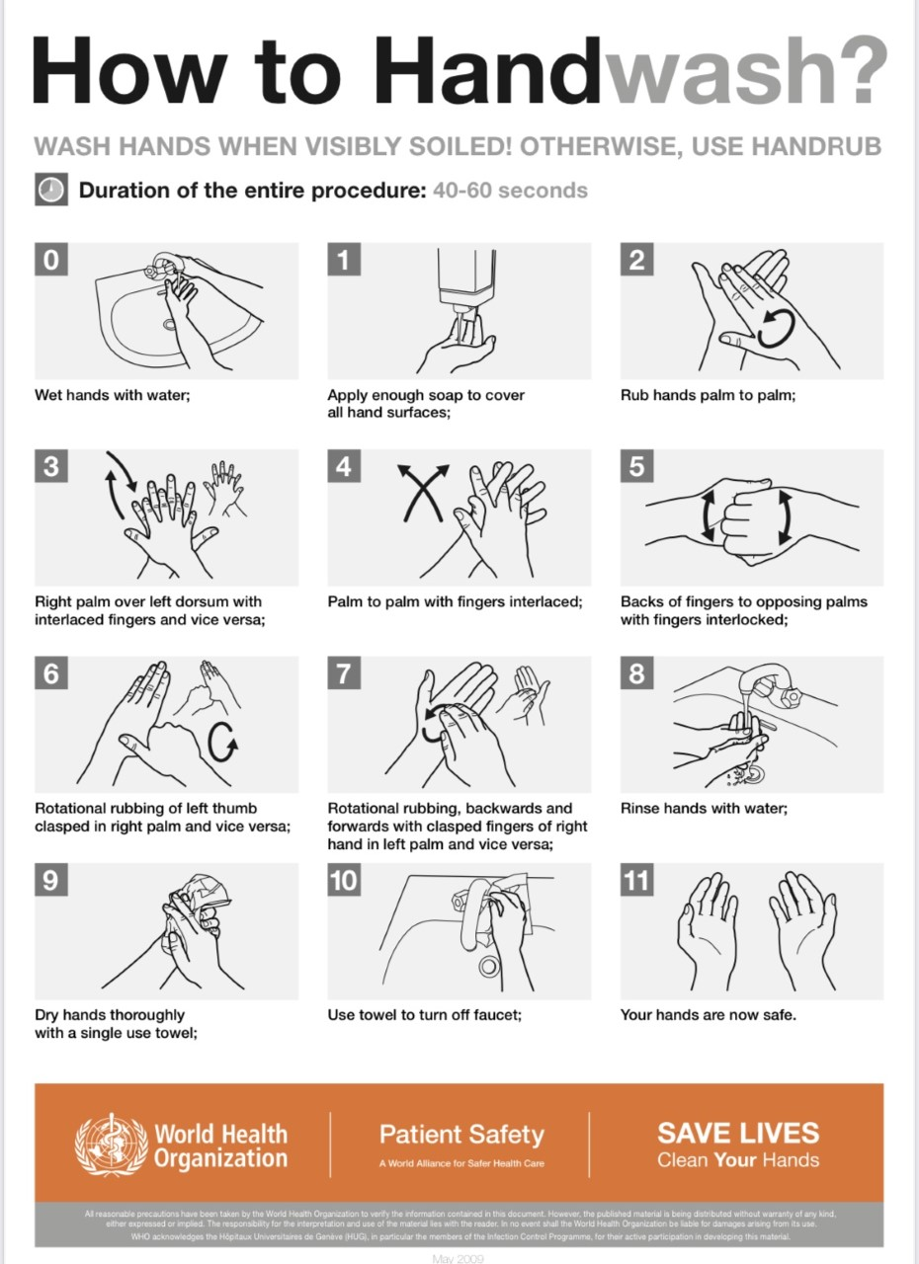
Appendix 1
Appendix 2

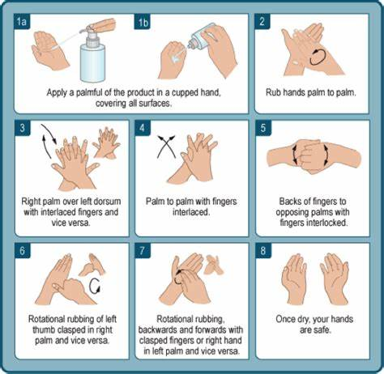
Adopted from the WHO

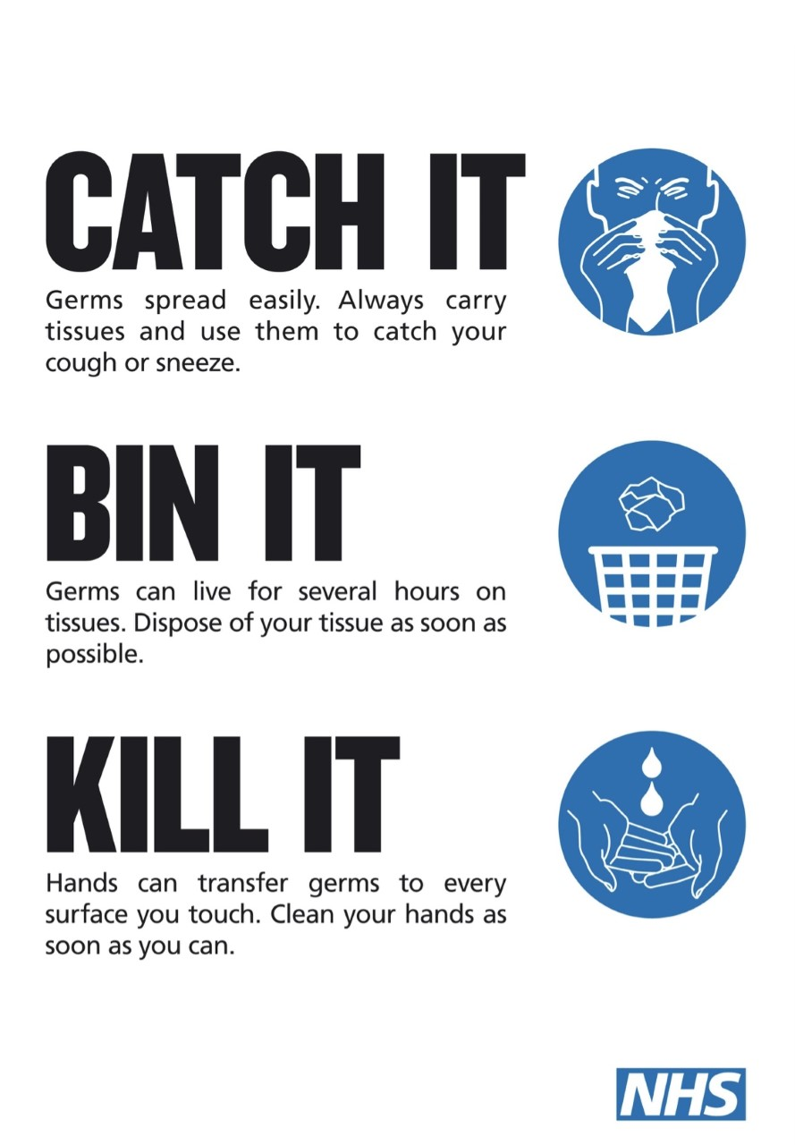
Appendix 3
Appendix 4

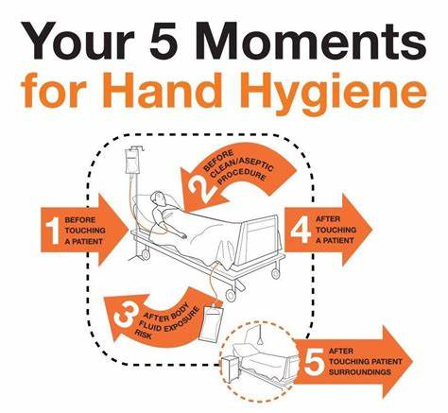

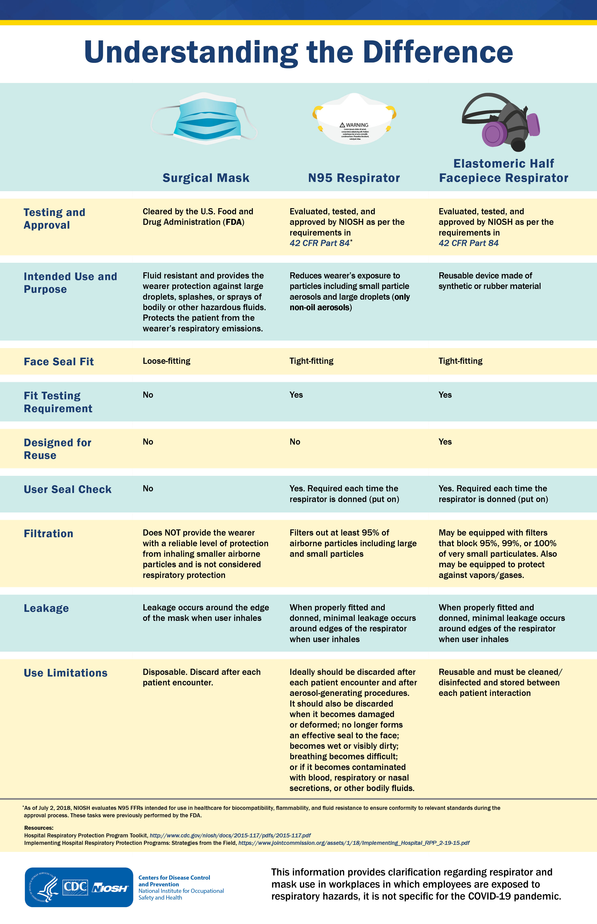
Appendix 5

